Advanced Games Programming
Tutorial 05 - World, View and Projection Transformations and Matrices

Introduction

Last time you looked at how to use constant buffers to pass information to a shader. You will use the same technique in this tutorial to pass transformation matrices to the shader that allow you to place objects in a 3D setting, move a virtual camera around and display the final resulting viewpoint on a 2D screen.

The Direct3D Coordinate System

In 3D graphics the position of any given vertex is specified by 3 coordinates, X, Y and Z. The concept of X and Y coordinates are likely familiar to you if you have ever drawn a graph. The 3rd coordinate Z represents a position along a third axis, the Z axis. When representing a 3D world onscreen using DirectX you can think of this axis as pointing into the screen, so that negative Z coordinates are "in front of the screen" and positive Z coordinates are "behind the screen". This is demonstrated in the diagram below, the black rectangle is on the XY axes and represents the screen, and the entire view has been offset to show the relationship:

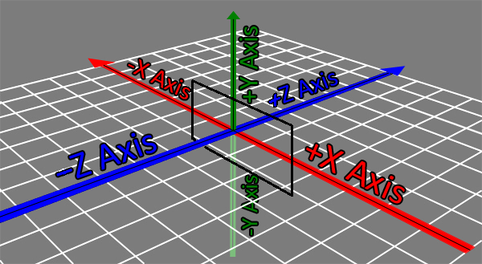

Direct3D uses a left-handed coordinate system, which means if you are looking along the z axis, when you have positive x values to the right and positive y values upwards then positive z values move away from you. A good way to see this, and the reason it is called a left-handed system, is to hold out your left hand as below, with the thumb representing the x axis, the index finger the y axis and the middle finger the z axis:

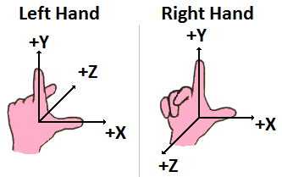

As you can see if you point the thumb to the left and the index finger upwards, the middle finger points away you, which indicates positive z values are going away you. As you might expect there is another coordinate system called right-handed, where the positive z values move towards you, as shown using the right hand in the diagram. It's important to note which coordinate system you are using, as different tools and APIs may use either one, and you might get unexpected results. Probably the most likely one you'll come across is OpenGL, which uses a right-handed system. Neither way is better than the other, there are a few differences in how matrices are represented and operated on, and how z buffers operate but you'll find that to convert from one to the other requires nothing more than a simple matrix transformation.

Model Space and World Space Transformations

When a 3D model is being built the object will generally be created about the (0, 0, 0) point in the modelling tool. The vertices that describe a 3D model exist in what is called Model Space. Clearly if you had several models all created around the (0, 0, 0) point and tried to draw them they would overlap, so it is necessary to move them into World Space. This space describes the absolute position and orientation of an object in the 3D World, and the movement is called the transformation from model space to world space.

There are several types of transformation that can be applied to a model, including translation, rotation and scale. The diagram below shows a basic translation transformation of an object from model space to world space:

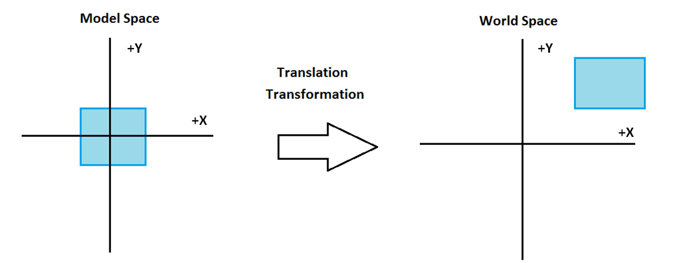
The above transformation consists of a translation along the x and y axes. You can also perform a rotation transformation:
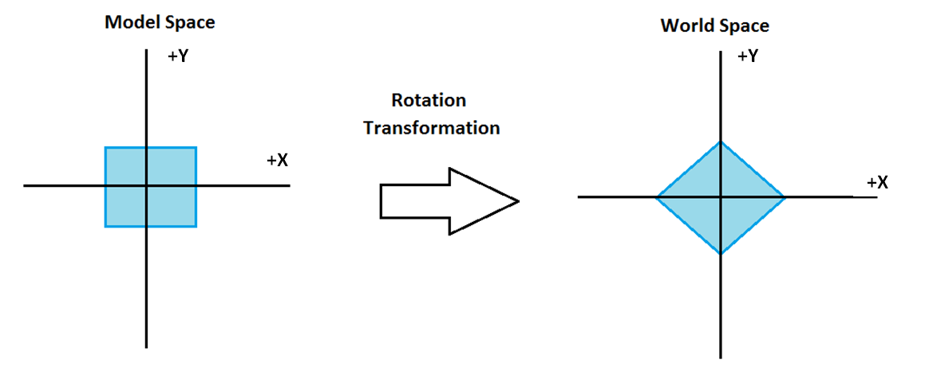
In this example the model is rotated 45 degrees around the Z axis (which is perpendicular to the page), but rotations can be done about any axis as required.

A scaling transformation can be performed for each axis too, so in the following example the model has been scaled by double along the y axis:

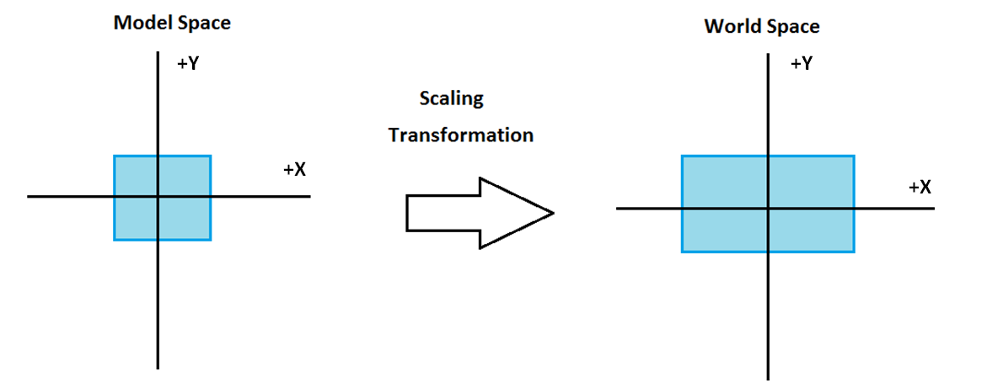
Finally transformations can be combined, so the following represents a rotation of 45 degrees, followed by a translation along the x and y axes:
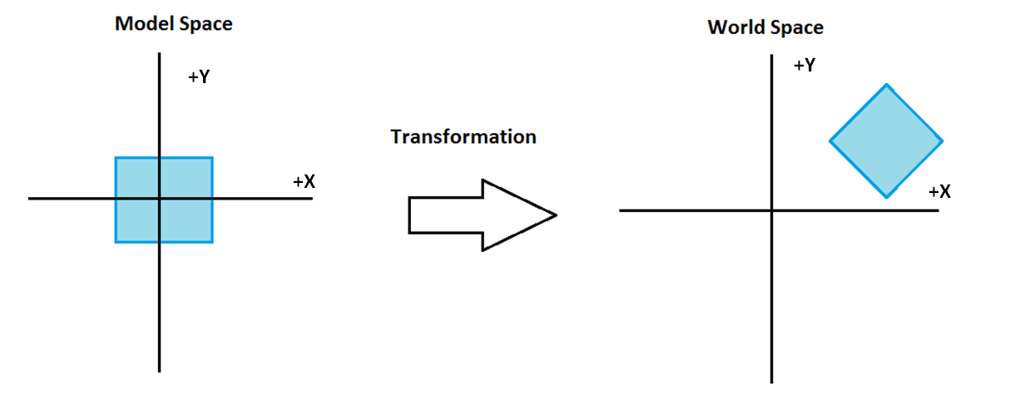

View Space Transform

World space transformations allow you to move objects in a 3D world, but unless you want the view of the 3D world to remain static you need some mechanism to move the viewpoint around. This can be imagined as orienting and moving a virtual camera through the 3D world, and this is represented by a View Space transformation that moves points from world space into a space where the viewpoint or camera is at (0, 0, 0). In essence you create a matrix that represents the position of your virtual camera, and the direction it is pointing, e.g.:

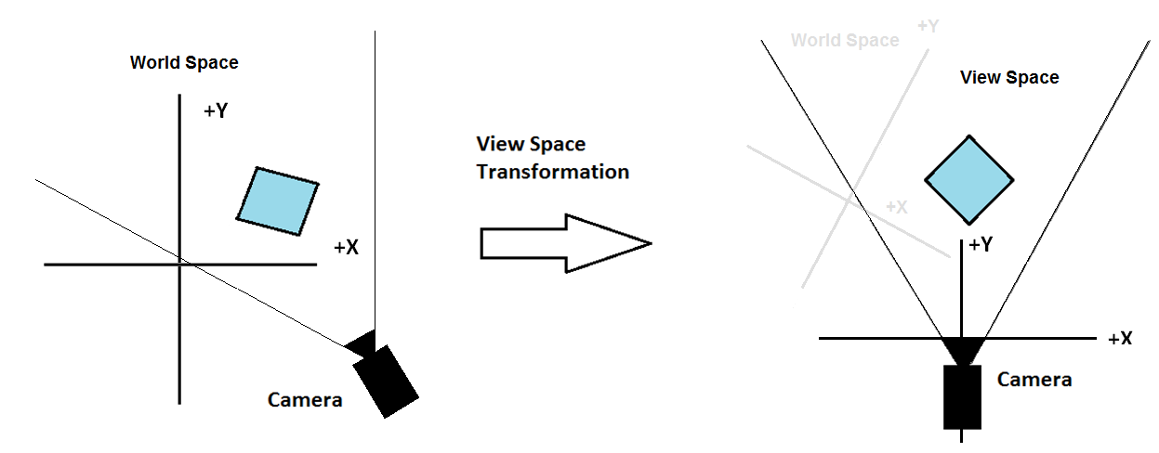

Perspective Projection Transform

In order to represent the objects in a 3D world on a 2D screen there needs to be some way of projecting them onto the screen, to remove objects that aren't visible from the camera, as well as scaling objects so they appear smaller as they are further away from the viewpoint. This is done using the Perspective Projection transform. This is calculated using the field of view of the virtual camera, the screen width and height in pixels, and the minimum and maximum z distance that objects should be visible. As an example, imagine the two squares in the left hand diagram are 3D cubes. The right hand diagram approximates what might appear onscreen after the perspective projection - cube 1 appears smaller than cube 2 as it is further away from the camera, and cube 3 is not visible at all:

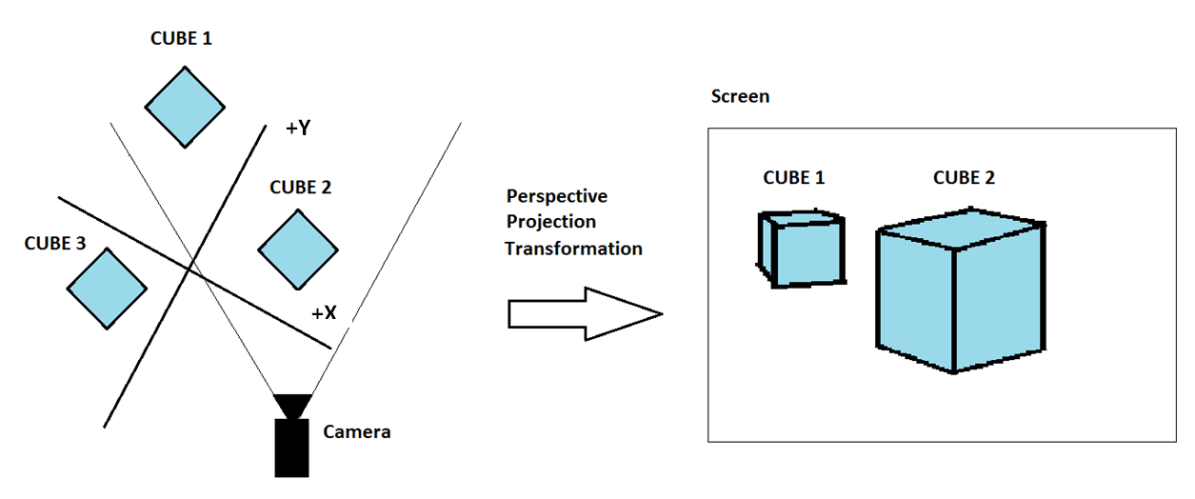

Using Matrices to Represent Transformations

In order to represent transformations Direct3D uses matrices. For the purposes of 3D graphics a transformation matrix is a 4x4 array of numbers that can be used to store a given transformation. Matrices can be multiplied together (or concatenated) in order to create a single transformation matrix that performs a combination of operations. One of the structures you can use in Direct3D to represent matrices is XMMATRIX, and there are functions provided that allow various matrices to be created, such as:

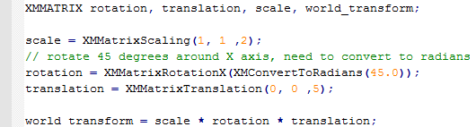

The final world transform here is the result of those 3 transformations applied in that order. If you change the order you will almost certainly get different results.

In order to create View and Perspective Projection matrices you can use other specialised functions. For now you won't be moving the viewpoint, so the View matrix can be set to the identity matrix. The identity matrix is a form of matrix that essentially does nothing when multiplied with other matrices, just like multiplying any number by 1 results in the same number.

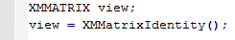

To create the projection matrix you can use the following:

The first of the parameters is the angle of the field of view (FOV). The FOV represents the horizontal angle that the camera can see, so for instance an approximate FOV of 60 degrees:

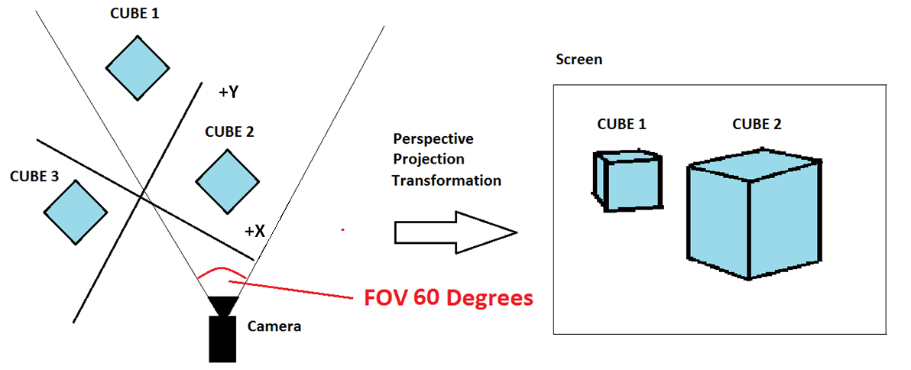

and alternatively with an approximate FOV of 20 degrees:

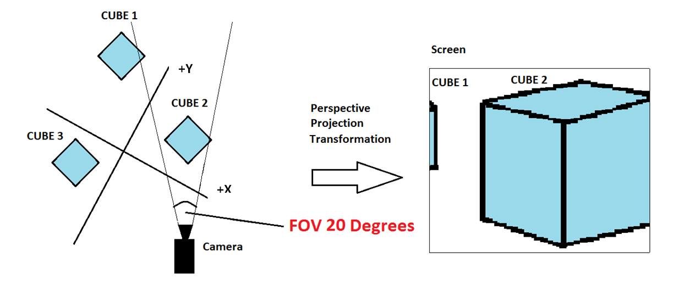
The second parameter is used to determine the vertical field of view. In order to keep the horizontal and vertical FOV ratio the same you generally use the current screen width divided by the height in pixels. The final two parameters determine how far and near objects in z distance from the viewpoint will be eliminated from the scene. Objects closer than parameter 3 and further than parameter 4 are not rendered.

Once the world, view and projection matrices have been created they can be multiplied together to create a single transformation matrix that can be used to transform the vertices of an object from its model space directly to their projected position onscreen. This is simply done like so:

Using the WorldViewProjection Matrix

In order to use the WorldViewProjection matrix to transform vertices you need to upload it to the shader. This is done using the constant buffers you looked at in the previous tutorial, you'll need to add a matrix structure to the constant buffer that is sent to the shaders. Here's how it might be done if added to the previous tutorial exercise:

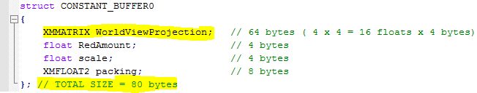

As the comments note an XMMATRIX is 64 bytes in size. As mentioned in the last tutorial there is a restriction that no single element should cross a 16 byte boundary in the structure, but obviously an XMMATRIX is always going to cross several boundaries. In these cases the rule is just to make sure it starts on a 16 byte boundary.

The size of the matrix must be taken into account of during the constant buffer creation, else the correct amount of data will not be uploaded:

The change to the constant buffer needs to be reflected in the shader declaration:

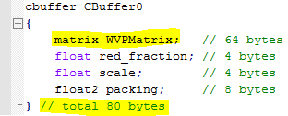

and then to use the matrix to transform vertices simply multiply them like so in the vertex shader:

The mul() function multiplies a vertex model space position by a matrix, in this case the concatenated world, view and perspective matrix uploaded into the constant buffer.

Exercise 01 - Calculating and Using the WorldViewProjection Matrix
- Create a new project based on your Tutorial 04 Exercise 02 project (or one of the extra/advanced exercises), renaming it in the correct way.
- Update the constant buffer struct to include a WorldViewProjection matrix. Don't forget to take account of the restriction that no single element should cross 16 byte boundaries, except elements greater than 16 bytes in which case they should be aligned on 16 bytes boundaries. Also it is a good idea to ensure you pack your buffer to a multiple of 16 bytes. Remember to update the byte width in the constant buffer creation code to reflect the new size, this must be a multiple of 16.
- In RenderFrame()add the following to the constant buffer update code to calculate the WorldViewProjection matrix and put it in the constant buffer structure. You may need to change the FOV ratio to suit your back buffer resolution, and will also need to update it if you want to handle window resize or fullscreen resolution changes (don't forget to ensure you pass a floating point value):
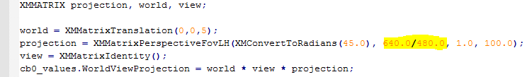
- The specific values used for the world translation above may not work if you have created your own triangles. If you don't see anything on screen the first thing to try will be use the original single triangle from a previous tutorial.
- Change the shader constant buffer declaration to include the WorldViewProjection matrix.
- Comment out any shader code that modifies the output position.
- Multiply the vertex position by the WorldViewProjection matrix in the vertex shader. (see above)
- Run the code a few times altering the variable world matrix z amount, say from 0.0 to 100.0, to see how it moves the triangle. Alternatively, add code that varies the value continuously, or via keyboard/mouse. Explain in your logbook and comments why the triangle changes in this way.
- Try altering the x and y values too.

Exercise 02 - Concatenating translations and rotations
- Create a new project based on your Tutorial 05 Exercise 01 project, renaming it in the correct way.
- Change the calculation of the world matrix to concatenate two individual translations:
What does this do? Does this do what you expected? Explain why.

- Change the code to this
Explain, with the assistance of diagrams why this results in a different output onscreen

Exercise 03 - Backface culling
- Create a new project based on your Tutorial 05 Exercise 02 project, renaming it in the correct way.
- Change the calculation of the world matrix to rotate around the X axis:
- Make degrees a floating point variable that continually varies or can be varied by keypress.
- What happens when degrees becomes greater than 90? Can you explain why? (Hint: back face culling)

